|  |
| --- |
| AIM Duration: 3 hours |
| * Create your resume using edit commands in document. |

|  |
| --- |
| LEARNING OUTCOME |
| Able to create document spread sheet and make presentation using open office. |

|  |
| --- |
| REQUIREMENT |

|  |
| --- |
| List of Hardware/Software requirements:   * Computer Desktop/Laptop * Windows Operating system * Open Office |

* PROCESDURE:
* Step 1: Open the MS word.
* Step 2: Take a blank sheet.
* Step 3: Insert your passport size photo and add on the top left corner as show on (Image 1).
* Step 4: Type your name on the top middle of the page with your Address.
* Step 5: Now add your contact no. and email as show on (Image 1).

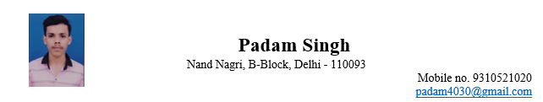

(Image 1)

* Step 6: Insert a row and type inside About me as show on (Image 2).

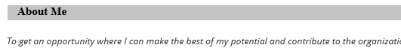

(Image 2)

* Step 7: Insert a row and type inside Education and take a more columns as show on (Image 3). Write down about your education

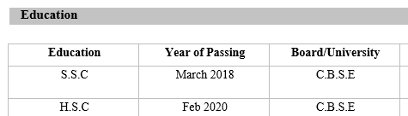

(Image 3)

* Step 8: Insert a row and type inside Skills and write down about your skills as show on (Image 4).

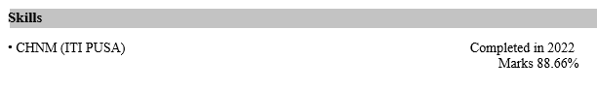

(Image 4)

* Step 9: Insert a row and type inside work experience as show on (Image 5).

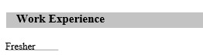

(Image 5)

* Step 10: Insert a row and type about your Croficiency as show on (Image 6).

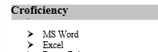

(Image 6)

* Step 11: Insert a row and mention about your languages as show on (Image 7).

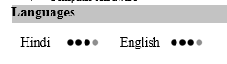

(Image 7)

* Step 12: Insert a row and write down yours personal Details as show on (Image 8).

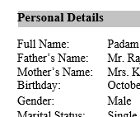

(Image 8)

* Step 13: Insert a row and type inside Declaration ass show on (Image 9).

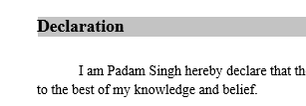

(Image 9)

* Step 14: This is the last step of resume gives a place name, date and your name as show on (Image 10).

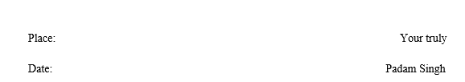

(Image 10)